Draft email – please add your logo
Dear PMNCH,

We are emailing in support of the Stillbirth Advocacy Working Group and the International Stillbirth Alliance to state that the 2021-2025 PMNCH Strategy under Phase 2 consultation does not adequately include stillbirths, and to request 7 specific changes.

Each year, there is a similar number of stillbirths (2.6 million in 2015) as there are neonatal deaths and post-neonatal deaths of children under-5 (2.5 million and 2.8 million, respectively). Stillbirths, 98% of which occur in low and middle income countries, remain a substantial, largely under-counted adverse pregnancy outcome. While maternal and childhood mortality rates have decreased in most regions, the stillbirth reduction rates are still too slow to meet the Global Strategy target of 12 per 1000 by 2030. Most stillbirths occur at or near term, half are intrapartum, and these deaths are largely preventable with access to quality health care. The lack of progress for stillbirths has less to do with the unfinished agenda of the Millennium Development Goals (MDGs), and more to do with political will and awareness around ensuring stillbirths are appropriately included in action on women’s, children’s and adolescents’ health (WCAH). We call on PMNCH to appropriately include stillbirths in your new 5-year strategy, not just as a toothless add-on to the unfinished agenda, but as a political challenge, as has been done for Sexual and Reproductive Health & Rights (SRHR), and as a growing and largely unaddressed issue, as has been done for Adolescent health and well-being.

Request #1: Add one word to the vision and mission.
Current vision and mission:
- The vision of PMNCH is ‘A world in which every woman, child and adolescent realizes their right to health and well-being, leaving no one behind’.
- The mission of PMNCH is ‘To mobilize, align and amplify the voice of partners to advocate for women’s, children’s and adolescents’ health and well-being, and a focus on the most vulnerable’.

SAWG proposed vision and mission:
- The vision of PMNCH is ‘A world in which every woman, child and adolescent realizes their right to survival, health and well-being, leaving no one behind’.
- The mission of PMNCH is ‘To mobilize, align and amplify the voice of partners to advocate for women’s, children’s and adolescents’ survival, health and well-being, and a focus on the most vulnerable’.

We understand the concern over lengthening the Vision and Mission statement by adding the word “survival”. However, as the SAWG explained in a recent Rapid Response to the BMJ collection “Leave no one behind”, one of the reasons stillbirths continue to be left behind is exactly because they are not explicitly mentioned sufficiently in high-level documents. The reasons for the continued exclusion of stillbirth have been well-researched and presented in The Lancet Ending Preventable Stillbirths series.

If “stillbirth” is not clearly included in PMNCH’s vision and mission, the promise represented by PMNCH’s new stated focus on ending preventable stillbirths will fall short. Our experience unfortunately shows that when stillbirth is not clearly mentioned at the highest levels, it is forgotten. As we wrote in our Rapid response to the BMJ “Leave no one behind” collection, silence around stillbirth persists in many important policies and reports, driving the continued lag in progress. The SDGs excluded stillbirth, and we can see the repercussions of this omission in the inadvertent exclusion of the stillbirth rate as an indicator of the PMNCH draft strategy that purports to focus on stillbirth! The BMJ collection on “Leave no one behind” ironically left 2.6 million stillbirths behind by making no mention of them at all in the collection’s 16 documents, including the headline piece by WHO’s DG Ghebreyesus.

We understand there are many competing concerns and interests as you work hard to finalize this document. If it is simply not possible to include the phrase “with no preventable newborn deaths and stillbirths”, then we strongly urge you to at least include the single word “survival” in both vision and mission. Consider that current wording, with the phrase “women, children and adolescents”, is not understood by most people to include “stillbirth”. Consider that for a stillbirth, all that is needed is to be born alive—survival. Consider that for a stillbirth, “health and wellbeing” make no sense, as the baby is not even born alive. Consider that “health and wellbeing” presuppose a live birth. It is clear that the vision and mission simply do not include stillbirths as they are now written—because “children” is not understood to include “stillbirths”, and “health and wellbeing” are irrelevant for stillbirths. Including the word “survival” will also align nicely with the Global Strategy’s focus on “survive and thrive”.

The PMNCH’s new 5-year strategy document presents a great opportunity to avoid repeating the error of omission that has contributed to stillbirth’s low global profile, by ensuring that stillbirths are explicitly included at the highest level in the strategy—the vision and mission—as it is the vision and mission that set the tone for the entire strategy. Including “survival” in the vision and mission will demonstrate PMNCH’s commitment to ensuring stillbirths are included in their strategy moving forward.

Request #2: Clearly define WCAH to include stillbirth.
Please add a text box to the Introduction of the strategy stating that:

“PMNCH defines Women’s, Children’s and Adolescents’ Health (WCAH) to include Newborns and Stillbirths”.

Request #3: Revise objectives to ensure integration instead of fragmentation.
Current objectives:
- Maternal, Newborn & Child Health (MNCH): amplifying action to reduce preventable MNC mortality and morbidity, including stillbirths, by stimulating the integration of essential WCAH interventions in UHC and enhancing high-quality services
- Sexual, Reproductive Health & Rights (SRHR): enhancing and aligning advocacy to uphold essential SRHR WCAH interventions and ensure continuous progress on financing and equitable access to comprehensive SRHR WCAH packages
- Adolescents: advancing the WCAH health and well-being of adolescents by engaging, aligning and capacitating partners around the Adolescent Health and Well-Being Framework and related policy and action

Our concern with the objectives currently is that (1) they treat MNCH, SRHR and Adolescent health as separate entities, and will inadvertently perpetuate a silo-like approach, and (2) they imply that integration of interventions is only important for MNCH, financing is only important for SRHR, and partner alignment is only important for adolescent health. This doesn’t make sense. Clearly, integration of interventions is just as important for SRHR and adolescent health as it is for MNCH. Clearly, financing is just as important for MNCH and adolescent health as it is for SRHR. And clearly, partner alignment is just as important for MNCH and SRHR as it is for adolescent health.

The need to have integrated rather than fragmented objectives in PMNCH’s 5-year strategy also directly relates to stillbirth. Just like adolescents, and other components of MNCH, stillbirth also requires enhanced and aligned advocacy to ensure continuous progress on financing and equitable access. There is a huge funding gap for stillbirth, which was only mentioned four times in the OECD database for ODA for WCAH in the 12-year funding period from 2002-2013 (Froen et al 2016). Stillbirths are also an issue of equity, as most of these deaths occur in low- and middle-income countries (98%) and in rural areas (60%), and many in conflict and emergency zones, affecting the families most underserved by healthcare systems (J. E. Lawn et al., 2016a), with the risk of stillbirth highest for the most marginalised populations in all settings: social disadvantage is associated with a doubling of the risk of stillbirth in high-income countries, an effect that is likely to be even greater in LMIC (Flenady et al., 2016b). This disparity reflects structural inequalities, including racism and inequity of opportunity. Finally, just like other components of MNCH and adolescent health, stillbirth also requires engagement with, alignment of and capacitation of partners, in support of the Lancet’s Ending Preventable Stillbirths Call to Action and the Every Newborn Action Plan; this need is reflected in the disappointing statistic that stillbirths remain absent in 61 of 90 national plans tracked by ENAP.

We propose the following easy “fix”, which retains the essence of the objectives while avoiding the counterproductive disjointing of MNCH, SRHR and adolescents, which are of course inherently linked.

SAWG proposed objectives (identical wording to current objectives is bolded):
- Objectives to build a movement for WCAH:
  - ensure integration of essential WCAH interventions in UHC and enhance high-quality services;
  - ensure continuous progress on financing of and equitable access to comprehensive WCAH packages;
  - engage, align and enable partners around WCAH policy and actions.

Request #4: Add qualifying text to the Results Framework
The problem with using the SDGs to track impact is that the SDGs exclude stillbirth. Please add the following qualifying text to the Results Framework section of the Strategy:

“Whilst no specific target for stillbirths was included in the SDGs, Goal 3.2 (ending preventable deaths of children) also covers reduction of perinatal mortality rates which comprise stillbirths plus early neonatal deaths. This is recognised in the UN Global Strategy for Women’s Children’s and Adolescent Health (where stillbirth is a core indicator) and Every Newborn Action Plan (which set a national target for stillbirth reduction, alongside the SDG 3.2 neonatal mortality target). MNH interventions impacting on SDG3 targets for neonatal mortality, also impact on stillbirth mortality. In view of substantial misclassification between stillbirths and early neonatal deaths, it is recommended that stillbirth rates and perinatal death rates (stillbirths plus early neonatal deaths) are tracked alongside neonatal mortality rates.”

Request #5: Add the stillbirth rate indicator to the text box of SDG indicators
Please use this revised text box which includes the ENAP/GS stillbirth rate indicator in the set of indicators that PMNCH will be tracking.
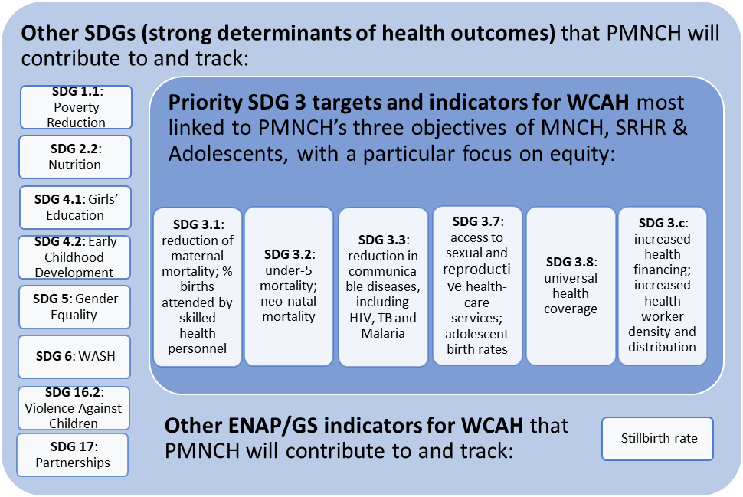

Request #6: Add the stillbirth rate indicator to Annex 4
Annex 4 is currently named “SDG targets & indicators (PMNCH impact measures)”. Please change this to “PMNCH impact measures” and add a new section to the table, in addition to the section on “SDG 3 indicators” and the section on “other SDG indicators”: add a section entitled “ENAP/GS indicators” and just put the stillbirth rate there. PMNCH does not need to repeat the mistakes of the past but can instead correct them by including the stillbirth rate as an indicator of its strategy, despite its exclusion from the SDGs.

Request #7: Ensure consistency in mentioning the linked burdens of stillbirth and MNC mortality
Please ensure that the burden of stillbirth is always mentioned along with maternal, newborn and child mortality throughout the document.

Thank you for taking forward our recommendations in order to strengthen your strategy for collective action.

Sincerely,

Signed, organization

